SIMATS ENGINEERING (SAVEETHA SCHOOL OF ENGINEERING)
Department of Computer Science and Engineering
CO2 ASSESSMENT TOOL 2 – Architecture Design Assignment

Course Code: | CSA10 / CSA1063 | Course Title: | Software Engineering
CO Assessed: | CO2 | Assessment: | Assessment Tool 2 – Architecture Design Assignment
Weightage: | 20% | Total Marks: | 25
CO2 Statement: | Perform detailed requirements analysis, design scalable architectures, and prioritize features with a focus on cross-disciplinary skills
Student Name: | M. Meghana | Reg. No.: | 192472351
Date: | 24/10/2026 | Duration: | 60 minutes

Code of Conduct
I M. Meghana – 192472351 certify that this submission is my original work and that I have adhered to the guidelines specified for this assessment. I understand that any violation of academic integrity rules will result in disciplinary action.
Signature of the Student: M. Meghana
Annexure A – Architecture Design Assignment
Instructions to Students:
Each student will be assigned an individual software project problem statement. Based on the assigned problem, analyze the system requirements and design an appropriate software architecture by applying software engineering principles. Your submission should demonstrate your ability to select, justify, and evaluate a suitable architectural style.

Question
Based on your assigned problem statement, perform an Architecture Design Analysis and prepare an architecture design report by answering the following questions:

1. Analyze System Requirements
- Study the given problem statement and identify the system objectives.
- Analyze the functional and non-functional requirements that influence the software architecture.
- Identify key quality attributes such as scalability, maintainability, reliability, availability, performance, and security.

2. Select a Suitable Software Architecture
- Select an appropriate architectural style for the proposed system (e.g., Layered Architecture, Client-Server, MVC, Microservices, Event-Driven, Service-Oriented Architecture, Serverless, or Hybrid Architecture).
- Justify why the selected architecture is the most suitable for the given problem.

3. Draw the Software Architecture Diagram
- Design a clear architecture diagram illustrating the overall structure of the proposed system.
- Include all major layers/components, databases, external systems, APIs, and communication mechanisms.
- Use appropriate software architecture notations and labels.

4. Explain Components and Their Interactions
- Describe the purpose and responsibilities of each architectural component.
- Explain how the components communicate and exchange data.
- Illustrate the overall workflow of the system.

5. Discuss Quality Attributes
Evaluate how the proposed architecture addresses the following aspects:
- Scalability
- Security
- Performance
- Reliability
- Maintainability
- Availability

6. Justify Architectural Decisions
- Explain the rationale behind your architectural choices.
- Discuss the trade-offs considered while selecting the architecture.
- Explain how the chosen architecture supports future enhancements, system integration, and long-term maintainability.
ANSWER:
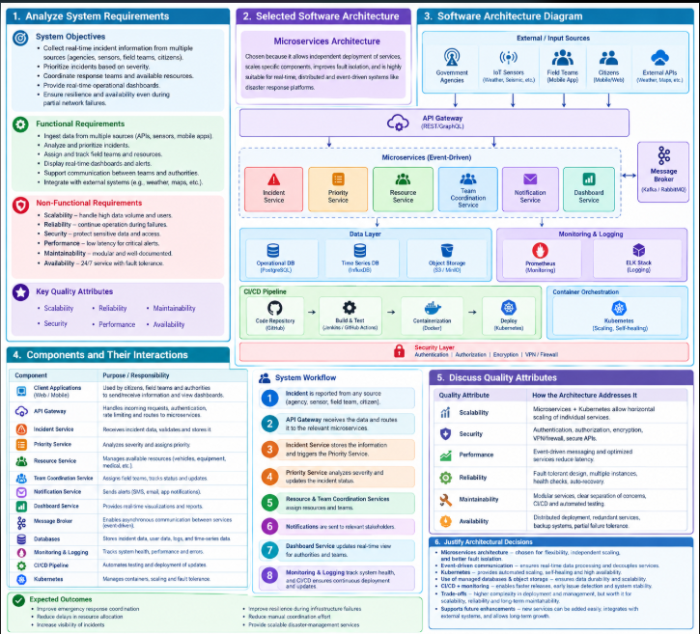
Smart Disaster Response and Emergency Coordination Platform
1. Analyze System Requirements
A. System Objectives
The main objective of this platform is to develop a smart, scalable, and reliable system that helps emergency authorities manage disasters effectively.
- Collect real-time emergency information from sensors, citizens, field teams, and government agencies.
- Identify and prioritize incidents based on their severity and urgency.
- Coordinate emergency response teams, vehicles, medical supplies, and other resources.
- Provide real-time dashboards to monitor incidents and response activities.
- Maintain essential services during network interruptions and partial system failures.
- Protect sensitive emergency information using secure access and data protection mechanisms.
- Support automated testing, deployment, monitoring, and logging.
B. Functional Requirements
Functional requirements describe what the system must do.
- Incident Collection: Receive emergency reports from multiple sources.
- Incident Prioritization: Classify incidents as critical, high, medium, or low priority.
- Resource Allocation: Assign suitable response teams and resources to incidents.
- Team Coordination: Share incident details, locations, and updates with field teams.
- Real-Time Dashboard: Display incident status, resource availability, and response progress.
- Notifications: Send alerts to authorities and response teams.
- Incident Management: Create, update, track, and close emergency incidents.
- Monitoring and Logging: Record system activities, errors, and service health.
- Security Management: Authenticate users and authorize access based on their roles.
- Deployment and Testing: Support automated software testing and deployment.

C. Non-Functional Requirements

Requirement | Description
Scalability | Handle increasing numbers of incidents and users.
Reliability | Continue processing essential operations despite failures.
Availability | Keep critical services accessible during emergencies.
Performance | Process incident reports and updates quickly.
Security | Protect confidential emergency and personal information.
Maintainability | Allow individual components to be updated easily.
Fault Tolerance | Handle service failures and network interruptions.
D. Important Quality Attributes: The architecture must focus on scalability, security, performance, reliability, maintainability, and availability. These attributes ensure that the platform remains effective during large-scale disasters.
2. Select a Suitable Software Architecture
Selected Architecture: Hybrid Microservices and Event-Driven Architecture
The proposed system uses a hybrid architecture combining microservices, event-driven communication, and a layered structure.
- Microservices architecture: Divides the platform into independent services such as incident management, prioritization, resource allocation, and notifications.
- Event-driven architecture: Uses a message broker to exchange incident updates and alerts asynchronously.
- Layered architecture: Separates user interfaces, application services, data storage, and security responsibilities.
Why this architecture is suitable
- Independent services: Each service can be developed, tested, and maintained separately.
- Scalability: Services handling large numbers of emergency reports can scale independently.
- Real-time processing: Events allow incident updates and notifications to be processed quickly.
- Fault tolerance: If one service fails, other services can continue operating where dependencies permit.
- Easy integration: APIs connect government agencies, sensors, mobile applications, and external systems.
- Continuous deployment: Containers and CI/CD pipelines support reliable software updates.
This architecture is appropriate because disaster management requires fast communication, distributed coordination, scalability, and continued operation during partial failures.
3. Draw the Software Architecture Diagram
The following architecture diagram shows how information moves from emergency sources through APIs and independent services to databases, dashboards, and monitoring tools.

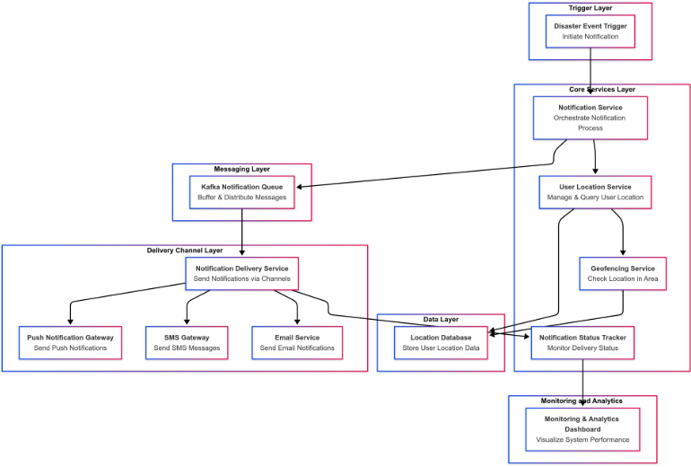
Architecture components
- Input Layer: Collects reports from government agencies, IoT sensors, citizens, and field teams.
- API Gateway: Receives requests, applies authentication and rate limits, and routes them to appropriate services.
- Microservices Layer: Processes incidents, prioritizes emergencies, allocates resources, coordinates teams, and sends notifications.
- Message Broker: Transfers events between services without requiring every service to communicate synchronously.
- Data Layer: Stores incident records, user details, historical information, and operational data.
- Dashboard Layer: Displays incident locations, severity, resource availability, and response status.
- Security Layer: Protects information using authentication, authorization, encryption, and secure communication.
- Monitoring and Deployment Layer: Uses logs, health checks, automated testing, CI/CD, and container orchestration to maintain the platform.
The diagram represents a proposed design. Technologies such as Docker, Kubernetes, PostgreSQL, and a message broker are suitable implementation choices, not requirements explicitly fixed by the problem statement.

Simplified Architecture Diagram
You can also draw this simpler diagram in your assignment if you need a clear, easy-to-copy version.
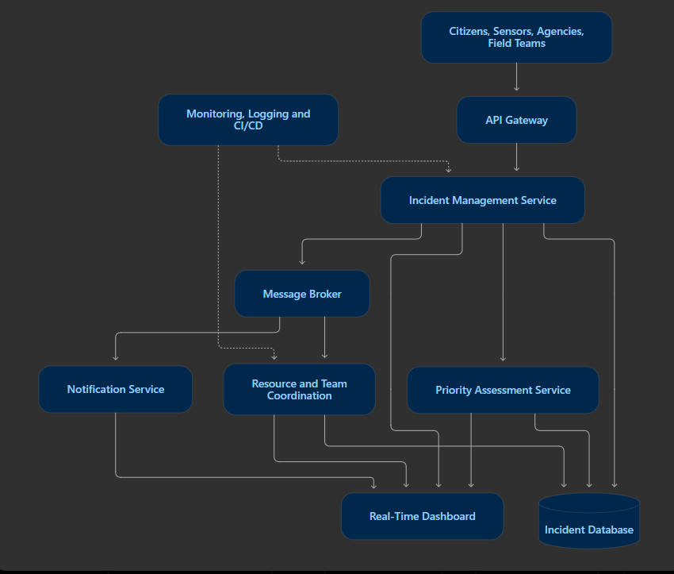

4. Explain Components and Their Interactions
A. Component Responsibilities

Component | Purpose
Client Applications | Allow citizens, field teams, and authorities to submit and view emergency information.
API Gateway | Routes requests to appropriate services and applies security checks.
Incident Service | Receives, validates, and stores emergency reports.
Priority Service | Classifies incidents based on severity and urgency.
Resource Service | Tracks and allocates vehicles, equipment, medical supplies, and other resources.
Team Coordination Service | Assigns response teams and tracks their progress.
Notification Service | Sends alerts and emergency updates to relevant users.
Dashboard Service | Displays incidents, priorities, team status, and resource availability.
Message Broker | Transfers events between services asynchronously.
Database | Stores incident records, user information, and operational data.
Monitoring and Logging | Tracks system health, errors, performance, and operational activities.
CI/CD Pipeline | Automates testing, building, and deployment of software updates.

B. Interaction Between Components

1.Citizens, sensors, agencies, and field teams submit incident reports.
2.The API Gateway validates incoming requests and routes them to the Incident Service.
3.The Incident Service stores the report and publishes an incident-created event.
4.The Priority Service evaluates the severity and urgency of the incident.
5.The Resource and Team Coordination Services identify suitable resources and assign response teams.
6.The Notification Service sends alerts and status updates.
7.The Dashboard Service displays the latest incident information to emergency authorities.
8.Monitoring and logging tools track failures and service performance.

C. System Workflow Diagram

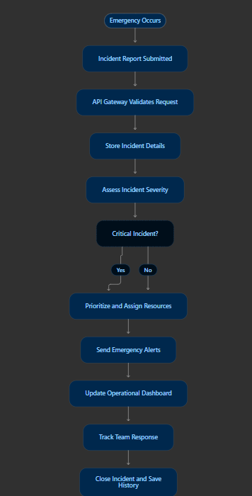

Workflow explanation:
The platform receives an emergency report, validates and stores the information, determines its priority, allocates resources, notifies response teams, and updates the dashboard until the incident is resolved.

5. Discuss Quality Attributes

Quality Attribute | How the Architecture Addresses It
Scalability | Independent microservices and container orchestration allow services to scale according to demand.
Security | Authentication, role-based authorization, encryption, and secure APIs protect sensitive information.
Performance | Asynchronous event processing, efficient database queries, and optimized APIs reduce delays.
Reliability | Health checks, retries, redundant service instances, and message persistence help handle failures.
Maintainability | Independent services, modular design, automated testing, and documentation simplify updates.
Availability | Redundant deployments, backups, failover mechanisms, and local data buffering help maintain essential services.

Handling Network Interruptions and Failures:
1.Buffer emergency reports locally when connectivity is unavailable.
2.Retry failed requests and messages with appropriate limits.
3.Maintain redundant instances of critical services.
4.Store important events durably so they can be processed after recovery.
5.Prioritize essential functions, such as critical alerts and incident tracking
6.Monitor service health and restore failed components automatically where possible.

These mechanisms reduce the impact of partial failures. Complete operation during every type of outage cannot be guaranteed; it depends on the infrastructure and recovery design.

6. Justify Architectural Decisions
A. Rationale for the Architecture
1.Microservices: Chosen because incident management, resource allocation, team coordination, and notifications have separate responsibilities.
2.Event-driven communication: Enables emergency information to be shared efficiently without tightly coupling all services.
3.API Gateway: Provides a common entry point for different applications and external systems.
4.Distributed data storage: Supports the storage and retrieval of incident information and historical records.
5.Containerization: Makes services easier to package and deploy consistently across environments.
6.Monitoring and logging: Help identify failures, investigate errors, and measure system performance.
7.CI/CD: Automates testing and deployment, reducing manual effort and deployment errors.
8.Security controls: Help ensure that only authorized personnel can access sensitive emergency information.

B. Trade-offs Considered

Advantages | Challenges
Independent service scaling | More complex service management
Better isolation of failures | Requires careful failure handling
Faster asynchronous processing | Event ordering and duplicate messages must be managed
Easier integration through APIs | APIs require security and version management
Automated deployment and testing | CI/CD pipelines require maintenance
Flexible future enhancements | Distributed monitoring and debugging can be difficult

C. Future Enhancements

• Integrate AI-based disaster prediction and risk assessment.
• Add GIS maps for incident locations and response routes.
• Integrate weather forecasts and satellite-based disaster information.
• Provide multilingual emergency notifications and voice support.
• Add predictive resource allocation based on historical incident data.
• Develop offline-capable mobile applications for field teams.
• Introduce advanced analytics for disaster planning and response evaluation.

Conclusion:
The Smart Disaster Response and Emergency Coordination Platform uses a hybrid microservices and event-driven architecture to collect emergency information, prioritize incidents, coordinate resources, and provide real-time dashboards. Security, monitoring, automated deployment, and fault-tolerance mechanisms help improve the platform’s reliability and availability. The proposed design supports efficient emergency management and can be extended with AI, geographic information systems, and predictive analytics in the future.

Rubrics for Calculation
Evaluation Criteria | Excellent (4 Marks) | Good (3 Marks) | Satisfactory (2 Marks) | Needs Improvement (1 Mark)
System Requirement Analysis (30%) | Thoroughly analyzes the problem statement, accurately identifies functional and non-functional requirements, and clearly explains quality attributes influencing the architecture. | Analyzes most requirements with minor omissions or limited explanation. | Identifies only basic requirements with partial analysis. | Requirement analysis is incomplete, inaccurate, or lacks clarity.
Selection of Software Architecture (25%) | Selects the most appropriate architectural style with strong technical justification aligned to system requirements. | Selects a suitable architecture with reasonable justification. | Architecture is partially suitable with limited justification. | Inappropriate architecture selected or justification is missing.
Architecture Diagram and Component Design (20%) | Produces a clear, complete, and well-structured architecture diagram with all major components, interfaces, and interactions accurately represented. | Diagram is mostly complete with minor omissions or notation issues. | Diagram includes only essential components and lacks sufficient detail. | Diagram is incomplete, unclear, or technically incorrect.
Component Interaction and Quality Attribute Analysis (15%) | Clearly explains component responsibilities, interactions, and thoroughly discusses scalability, security, performance, reliability, maintainability, and availability. | Explains most components and quality attributes with minor gaps. | Provides limited explanation of interactions and addresses only some quality attributes. | Component interactions and quality attributes are poorly explained or missing.
Architectural Justification and Technical Presentation (10%) | Provides strong justification for architectural decisions, discusses trade-offs and future enhancements, and presents a well-organized, professional report. | Provides adequate justification with minor gaps; report is well organized. | Limited justification with minimal discussion of trade-offs or future scope; report needs improvement. | Justification is weak or absent; report lacks organization and technical clarity.

Criteria | Mark
System Requirement Analysis (30%) | /5
Selection of Software Architecture (25%) | /5
Architecture Diagram and Component Design (20%) | /5
Component Interaction and Quality Attribute Analysis (15%) | /5
Architectural Justification and Technical Presentation (10%) | /5
TOTAL | /25

